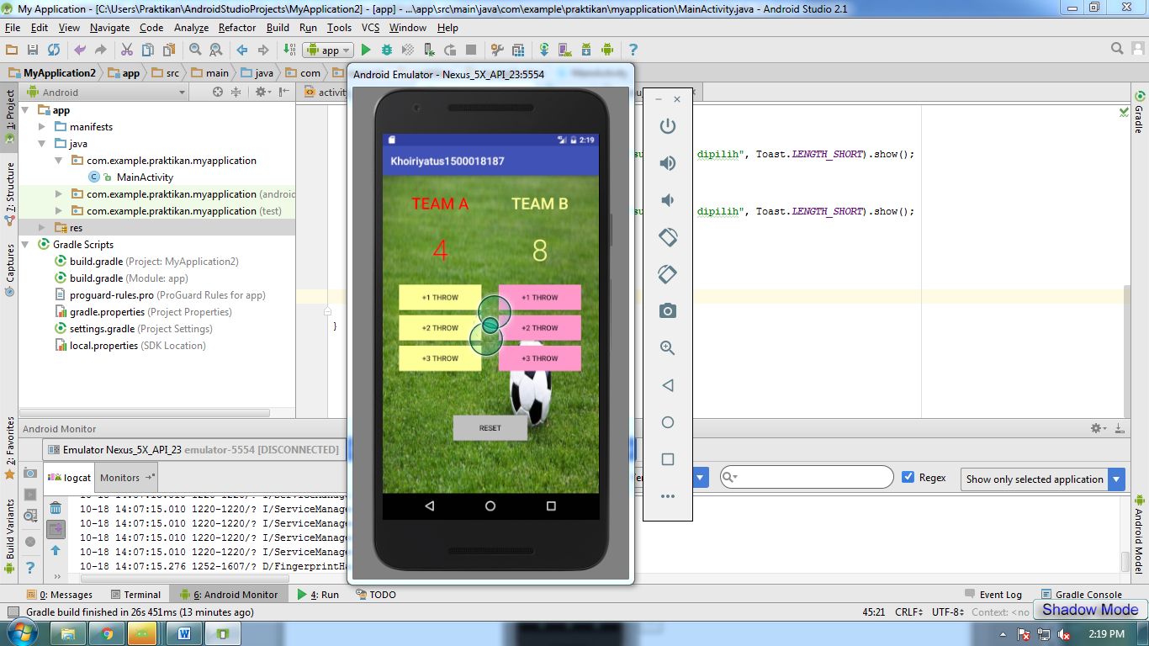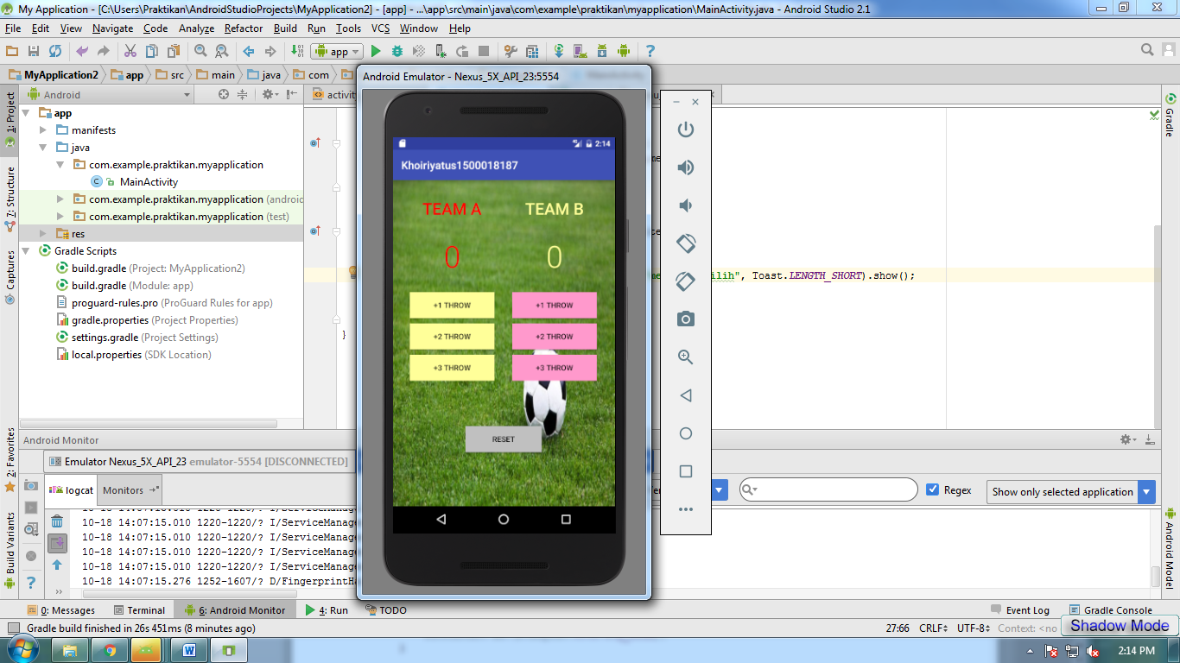

*<?***xml version="1.0" encoding="utf-8"***?>*<**LinearLayout xmlns:android="http://schemas.android.com/apk/res/android"  
 xmlns:app="http://schemas.android.com/apk/res-auto"  
 xmlns:tools="http://schemas.android.com/tools"  
 android:layout_width="match_parent"  
 android:layout_height="match_parent"  
 android:orientation="vertical"  
 android:background="@drawable/gambar"  
 tools:context="com.uad.khoiriyatus.MainActivity"**>  
  
 <**LinearLayout  
 android:layout_width="match_parent"  
 android:layout_height="wrap_content"  
 android:orientation="horizontal"** >  
 <**LinearLayout  
 android:layout_width="match_parent"  
 android:layout_height="wrap_content"  
 android:layout_marginRight="1dp"  
 android:layout_weight="1"  
 android:gravity="center_horizontal"  
 android:orientation="vertical"  
 android:padding="16dp"** >  
  
 <**TextView  
 android:layout_width="wrap_content"  
 android:layout_height="wrap_content"  
 android:fontFamily="sans-serif-medium"  
 android:text="Team A"  
 android:textAllCaps="true"  
 android:textColor="#ffff0000"  
 android:textSize="30sp"** />  
 <**TextView  
 android:id="@+id/team_a_score"  
 android:layout_width="wrap_content"  
 android:layout_height="wrap_content"  
 android:layout_marginTop="30dp"  
 android:fontFamily="sans-serif-light"  
 android:text="0"  
 android:textAllCaps="true"  
 android:textColor="#ffff0000"  
 android:textSize="56sp"** />  
 <**Button  
 android:layout_width="match_parent"  
 android:layout_height="wrap_content"  
 android:id="@+id/team_a_one_score"  
 android:layout_marginTop="30dp"  
 android:background="#ffffff99"  
 android:onClick="teamAOneScore"  
 android:text="+1 THROW"  
 android:textAllCaps="true"  
 android:textColor="#000"  
 android:textSize="14sp"** />  
 <**Button  
 android:id="@+id/team_a_two_score"  
 android:layout_width="match_parent"  
 android:layout_height="wrap_content"  
 android:layout_marginTop="10dp"  
 android:background='#ffffff99'  
 android:onClick="teamBTwoScore"  
 android:paddingLeft="20dp"  
 android:paddingRight="20dp"  
 android:text="+2 THROW"  
 android:textAllCaps="true"  
 android:textColor="#000"  
 android:textSize="14sp"** />  
 <**Button  
 android:id="@+id/team_a_three_score"  
 android:layout_width="match_parent"  
 android:layout_height="wrap_content"  
 android:layout_marginTop="10dp"  
 android:background="#ffffff99"  
 android:onClick="teamAThreeScore"  
 android:paddingLeft="20dp"  
 android:paddingRight="20dp"  
 android:text="+3 THROW"  
 android:textAllCaps="true"  
 android:textColor="#000"  
 android:textSize="14sp"** />  
 </**LinearLayout**>  
 <**LinearLayout  
 android:layout_width="match_parent"  
 android:layout_height="wrap_content"  
 android:layout_marginRight="1dp"  
 android:layout_weight="1"  
 android:gravity="center_horizontal"  
 android:orientation="vertical"  
 android:padding="16dp"** >  
  
 <**TextView  
 android:layout_width="wrap_content"  
 android:layout_height="wrap_content"  
 android:fontFamily="sans-serif-medium"  
 android:text="Team B"  
 android:textAllCaps="true"  
 android:textColor="#ffffff99"  
 android:textSize="30sp"** />  
 <**TextView  
 android:id="@+id/team_b_score"  
 android:layout_width="wrap_content"  
 android:layout_height="wrap_content"  
 android:layout_marginTop="30dp"  
 android:fontFamily="sans-serif-light"  
 android:text="0"  
 android:textAllCaps="true"  
 android:textColor="#ffffff99"  
 android:textSize="56sp"** />  
 <**Button  
 android:id="@+id/team_b_one_score"  
 android:layout_width="match_parent"  
 android:layout_height="wrap_content"  
 android:layout_marginTop="30dp"  
 android:background="#ffff99cc"  
 android:onClick="teamBOneScore"  
 android:text="+1 THROW"  
 android:textAllCaps="true"  
 android:textColor="#000"  
 android:textSize="14sp"** />  
 <**Button  
 android:id="@+id/team_b_two_score"  
 android:layout_width="match_parent"  
 android:layout_height="wrap_content"  
 android:layout_marginTop="10dp"  
 android:background='#ffff99cc'  
 android:onClick="teamBTwoScore"  
 android:paddingLeft="20dp"  
 android:paddingRight="20dp"  
 android:text="+2 THROW"  
 android:textAllCaps="true"  
 android:textColor="#000"  
 android:textSize="14sp"** />  
 <**Button  
 android:id="@+id/team_b_three_score"  
 android:layout_width="match_parent"  
 android:layout_height="wrap_content"  
 android:layout_marginTop="10dp"  
 android:background="#ffff99cc"  
 android:onClick="teamBThreeScore"  
 android:paddingLeft="20dp"  
 android:paddingRight="20dp"  
 android:text="+3 THROW"  
 android:textAllCaps="true"  
 android:textColor="#000"  
 android:textSize="14sp"** />  
  
 </**LinearLayout**>  
  
 </**LinearLayout**>  
  
 <**LinearLayout  
 android:layout_width="wrap_content"  
 android:layout_height="match_parent"  
 android:gravity="center"  
 android:layout_gravity="center"  
 android:orientation="vertical"** >  
 <**Button  
 android:layout_width="wrap_content"  
 android:layout_height="wrap_content"  
 android:layout_marginBottom="16dp"  
 android:background="#ffc0c0c0"  
 android:onClick="resetButton"  
 android:paddingLeft="50dp"  
 android:paddingRight="50dp"  
 android:text="Reset"  
 android:textColor="#000"  
 android:textSize="14sp"** />  
  
 </**LinearLayout**>  
  
</**LinearLayout**>

**package** com.uad.khoiriyatus;  
  
**import** android.support.v7.app.AppCompatActivity;  
**import** android.os.Bundle;  
**import** android.view.View;  
**import** android.widget.TextView;  
  
**public class** MainActivity **extends** AppCompatActivity {  
 **int scoreTemA** = 0;  
 **int scoreTemB** = 0;  
 @Override  
 **protected void** onCreate(Bundle savedInstanceState) {  
 **super**.onCreate(savedInstanceState);  
 setContentView(R.layout.***activity_main***);  
 }  
  
 */*  
 * Team A Code Started  
 * */* **public void** teamAOneScore(View view) {  
  
 **scoreTemA** = **scoreTemA** + 1;  
 displayForTeamA(**scoreTemA**);  
 }  
  
 **public void** teamATwoScore(View view) {  
 **scoreTemA** = **scoreTemA** + 2;  
 displayForTeamA(**scoreTemA**);  
 }  
  
 **public void** teamAThreeScore(View view) {  
 **scoreTemA** = **scoreTemA** + 3;  
 displayForTeamA(**scoreTemA**);  
 }  
  
 **private void** displayForTeamA(**int** score) {  
 TextView scoreView = (TextView) findViewById(R.id.***team_a_score***);  
 scoreView.setText(**""** + score);  
 }  
  
 */*  
 * Team B Code Started  
 * */* **public void** teamBOneScore(View view) {  
 **scoreTemB** = **scoreTemB** + 1;  
 displayForTeamB(**scoreTemB**);  
 }  
  
 **public void** teamBTwoScore(View view) {  
 **scoreTemB** = **scoreTemB** + 2;  
 displayForTeamB(**scoreTemB**);  
 }  
  
 **public void** teamBThreeScore(View view) {  
 **scoreTemB** = **scoreTemB** + 3;  
 displayForTeamB(**scoreTemB**);  
 }  
  
 **private void** displayForTeamB(**int** score) {  
 TextView scoreView = (TextView) findViewById(R.id.***team_b_score***);  
 scoreView.setText(String.*valueOf*(score));  
 }  
  
 *//Reset button code* **public void** resetButton(View view) {  
 **scoreTemA** = 0;  
 **scoreTemB** = 0;  
 displayForTeamA(0);  
 displayForTeamB(0);  
  
 }  
  
}